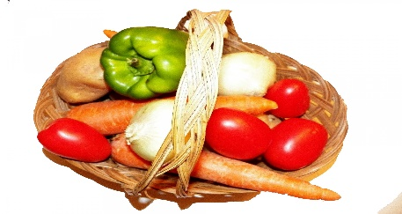The Dower House Menu For Week Commencing 13/06/2022

Monday 13th | Tuesday 14th | Wednesday 15th | Thursday 16th | Friday 17th | Saturday 18th | Sunday 19th
Chicken with Lemon and Tarragon Cream Sauce | Pork Fillet with Caramelised Apple and Black Pudding | Roast Lamb with Fresh Mint Sauce | Turkey Escalopes with a Bacon and Mushroom Cream Sauce | Hake Fillet with Parma Ham and a Lemon Butter Sauce | Cumberland Pie | Honey Roast Gammon with Fresh Parsley Sauce
Courgettes | Leeks | Cauliflower Gratin | Butternut Squash | Fennel | Summer Cabbage | Carrots
Green Beans | Celeriac | Peas | Turnips | Broccoli | Peas | Broad Beans
Sweet Potatoes | Sauté Potatoes | Roast Potatoes | Diced Potatoes | Herb Buttered Potatoes | Oven Baked New Potatoes | Roast Potatoes
Cherry Pudding and Custard | Queen of Puddings | Honey Roast Nectarines with Amaretti Crumb | Pineapple Upside Down Pudding with Custard | Strawberries, Cream and Shortbread | Crème Brûlée | Choice of Dessert
Afternoon Tea | Afternoon Tea | Afternoon Tea | Afternoon Tea | Afternoon Tea | Afternoon Tea | Afternoon Tea
Homemade Jam Doughnuts | Viennese Sandwich | Iced Lemon Cake | Buttered Tea Loaf | Victoria Sandwich | Dorset Apple Cake | Chocolate Fudge Cake
Supper | Supper | Supper | Supper | Supper | Supper | Supper
Vegetable Soup | Pea Soup | Courgette Soup | Carrot and Orange Soup | Celery Soup | Roast Butternut Squash Soup | Leek and Stilton Soup
Baked Egg | Cod and Parsley Croquettes | Cheddar and Watercress Scone with Chutney | Scampi with Tartare Sauce | Spinach and Cream Cheese Roulade | Smoked Chicken and Sweetcorn Fritters | Smoked Salmon with Brown Bread and Butter
OR | OR | OR | OR | OR | OR | OR
Cheddar and Chutney Sandwich | Tomato Sandwich | Egg and Cress Sandwich | Cream Cheese and Cucumber Sandwich | Corned Beef Sandwich | Brie and Grape Sandwich | Egg Mayonnaise Sandwich
Apple Snow | Prune Mousse | Strawberry Whip | Stewed Apple | Tropical Fruit Jelly | Poached Fruit with Crème Fraiche | Pineapple, Melon and Grape

